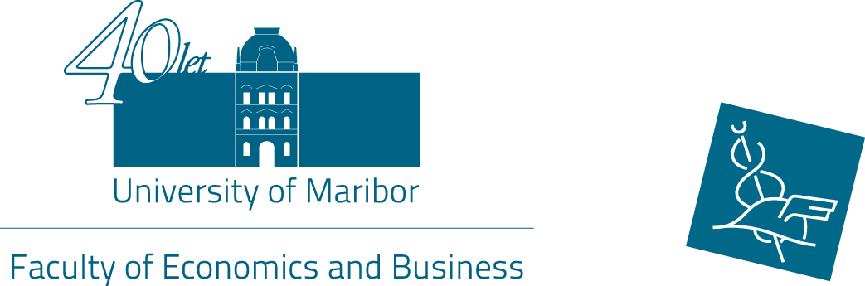

10th International week
Preliminary Programme
17 – 20 May 2016

May 17, Tuesday
Faculty of Economics and Business

8.30 Registration
Avla, Faculty of Economics and Business, Razlagova 14
9.00 Symposium opening adresses
Senate room, Razlagova 14

9.30 Symposium of foreign partner institutions representatives
Presentation of participants' home institutions

11.15 Coffee Break

11.30 Presentation of participants' home institutions

14.00 Lunch (Restaurant Hotel City, Kneza Koclja 22, Maribor)

16.00 City guided tour
19.00 Symposium dinner

May 18, Wednesday
Faculty of Economics and Business
Lectures (TSM), presentations (ST) and workshops by participants
Organized meetings with the Departments
17.00 Vinag wine cellar (tour and wine tasting)

May 19, Thursday
Faculty of Economics and Business
Lectures (TSM), presentations (ST) and workshops by participants
Organized meetings with the Departments

May 20, Friday
Faculty of Economics and Business
Lectures (TSM), presentations (ST) and workshops by participants
Organized meetings with the Departments

